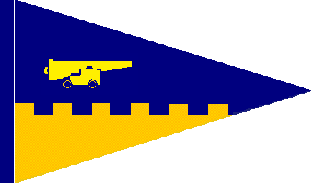 Antigua Yacht Club
English Harbour, Antigua, West Indies
Office Tel/Fax: (268) 460-1799
email: ayc@yachtclub.ag
website: www.antiguayachtclub.com
Amendment To Thursday Race Courses

Thursday Afternoon Series 2017-2018

The Courses are amended as below in the Highlighted text.

Inside course. 2.125 Miles
Start:- Red and Green Channel Mark (P) – 1st Green Cat Club Channel Mark (P) – Laid Mark in Dieppe Bay (P) – 1st Red Main Channel Mark (P) – Spit Shoal Red and Green Mark (P)
Laid Mark in Dieppe Bay (P) – Finish.

Inside course 2.
Start:- 1st Red Catamaran Channel Mark (P) – 1st Green Cat Club Channel Mark (P) – Laid Mark in Dieppe Bay (P) – 1st Red Main Channel Mark (P) – Spit Shoal Red and Green Mark (P)
Laid Mark in Dieppe Bay (P) – Finish.

Outside course. 3.9 Miles
Start:- Red and Green Channel Mark (S) – Spit Shoal Red and Green Mark (S) – 1st Red Main Channel Mark (P) – Bishops Reef Red Mark (P) – 1st Red Channel Mark in English Harbour (P) – Laid Mark in Dieppe Bay (S) – Finish.

Outside course 2. 3.9 Miles
Start:- Red and Green Channel Mark (S) – Spit Shoal Red and Green Mark (S) – 1st Red Main Channel Mark (P) – Bishops Reef Red Mark (P) – Laid Mark at the Entrance of English Harbour (P) – Laid Mark in Dieppe Bay (S) – Finish.

See course Charts for more guidance.

Signed
Richard Archer
AYC Fleet Captain

