Rocco Falcone & River Andrew just came back from
INTERNATIONAL OPTIMIST REGATTA IN STHOMAS
Total of 64 Competitors
12 Team for Team racing
Rocco & his Team came
2nd on Team Racing
Individual race after 11 races & 64 competitors was
8th overall
5th in Red Fleet
last race he had a great 1st
River & his Team came
5th in Team Racing
20th overall over 64 sailors
8th in Red Fleet
his best race was 12th
It was his first big aEvent and he did incredible good
Competition is a very high standard.
It was a great week.
Paola
http://www.regattanetwork.com/event/9323#_newsroom

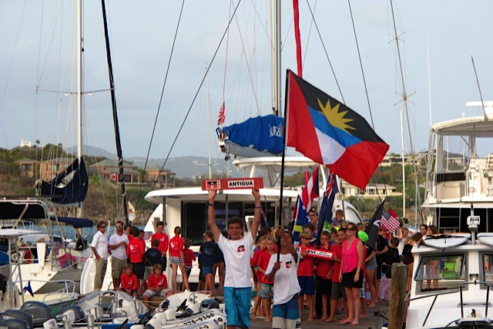
Open Ceremony
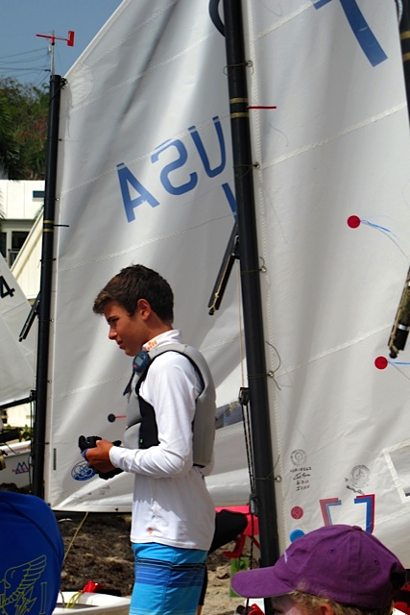

Rocco

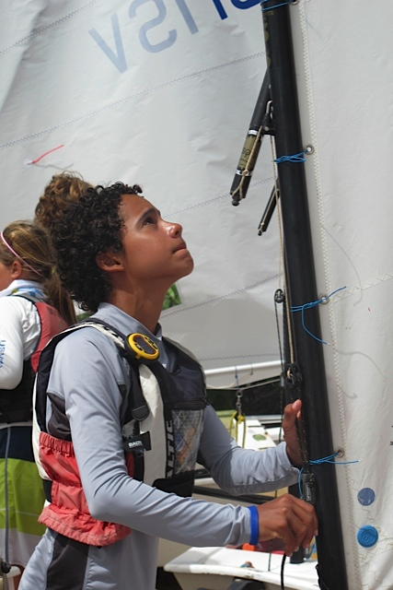
River

