Premier’s Cup International Youth Regatta
Six teams participated in the Premier’s Cup International Youth Regatta held in Tortola, BVI from the 18th to 20th of July. Teams included Anguilla, Antigua, Cayman Islands, Tortola I, Tortola II and Sail Caribbean (USA).
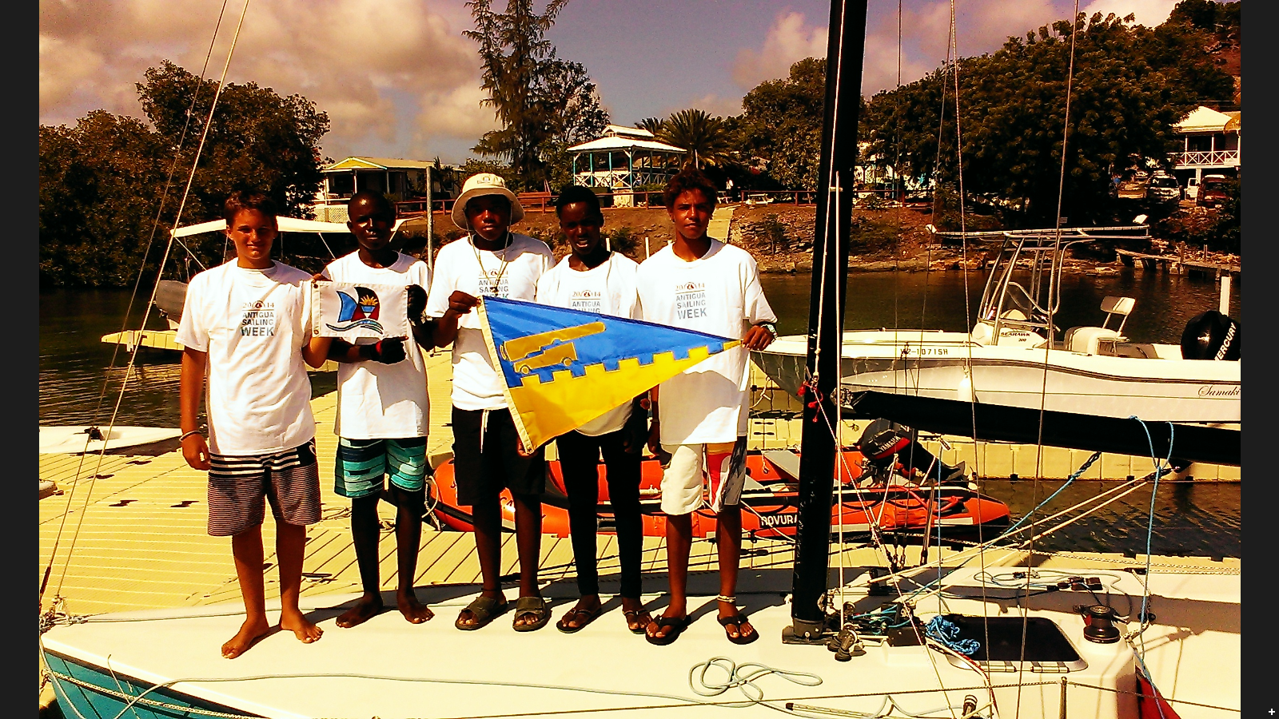
The youth sailors sailing on behalf of Antigua Yacht Club and Antigua’s National Sailing Academy included Jules Mitchell, Captain (15), Rhone Kirby (16), Vincent Anfi (14), Tyrese Loctar (14) and Abevia Parry (15). It was the first time that Jules had helmed for the team in an international regatta, representing a big step for him. Two members of the team participated in the 2013 Premier’s Cup Regatta – Jules Mitchell and Rhone Kirby.
The racing was exceptionally challenging. Team Antigua was a little disappointed with its results following Saturday’s racing but after great encouragement from coach Karl James, the team bounced back on Sunday and succeeded in scoring three 2nd place finishes.
Antigua’s youth prepared for a solid month in advance of the event, racing against each other in Cork 1720’s and even racing in RS Elites at Nonsuch Bay Resort on occasion. The confidence level was very high going into the Premier’s Cup and the team did exceptionally well in this challenging international event. Aside from the racing, there were also events on shore such as tug-o-war that the young sailors enjoyed participating in.
When the final results had been tallied, Team BVI I proved to be quite dominant and took the 1st place finish overall. Other results were - 2nd place Cayman Islands; 3rd place Anguilla; 4th place Antigua; 5th place Sail Caribbean (USA); 6th place Team BVI II.
The Premier’s Cup International Youth Regatta provided a fantastic opportunity for team Antigua to meet other Caribbean youth sailors at which new friendships and bonds were forged. Congratulations to all the youth sailors on another great experience in an international regatta.
Thanks go to Antigua Yacht Club and head coach Karl James; Antigua’s National Sailing Academy; and Antigua Sailing Week for donating the flights compliments of sponsor Liat, The Caribbean Airline.

