St Thomas International Optimist Regatta
60 competitors: 1 start line
10 races
Rocco came 13th overall
and 7th in red fleet
best race was 1st!
Louis came 22nd overall
9th in red fleet
best race 8th.
THANK YOU for supporting them
Kind regards
Paola
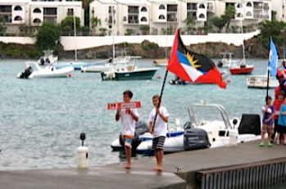

Rocco & Louis

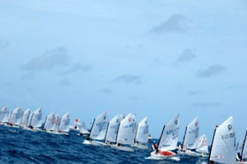

Start Line: Louis on the right , Rocco in the middle.

