European Optimist Championship, Ireland 2014
250 competitors
44 countries
Rocco 32th in silver fleet
overall 82nd
best race was 16th
Louis 36th in silver fleet
86th overall
best race was 5th(super result!)
Racing condition were crazy
wind shifts from 7knots to 25knots
fog, cold,sunny!!!
Great Event
Lots of new firends.
European Champion is Enzo, french sailor from Guadaloupe.!! good friend of the Louis & Rocco
Paola
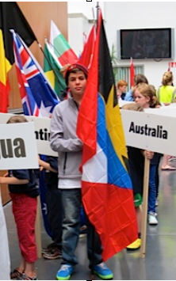
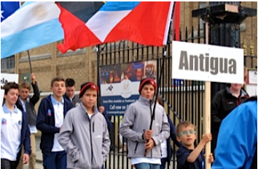
Open Ceremony – Antigua is always first

Rocco
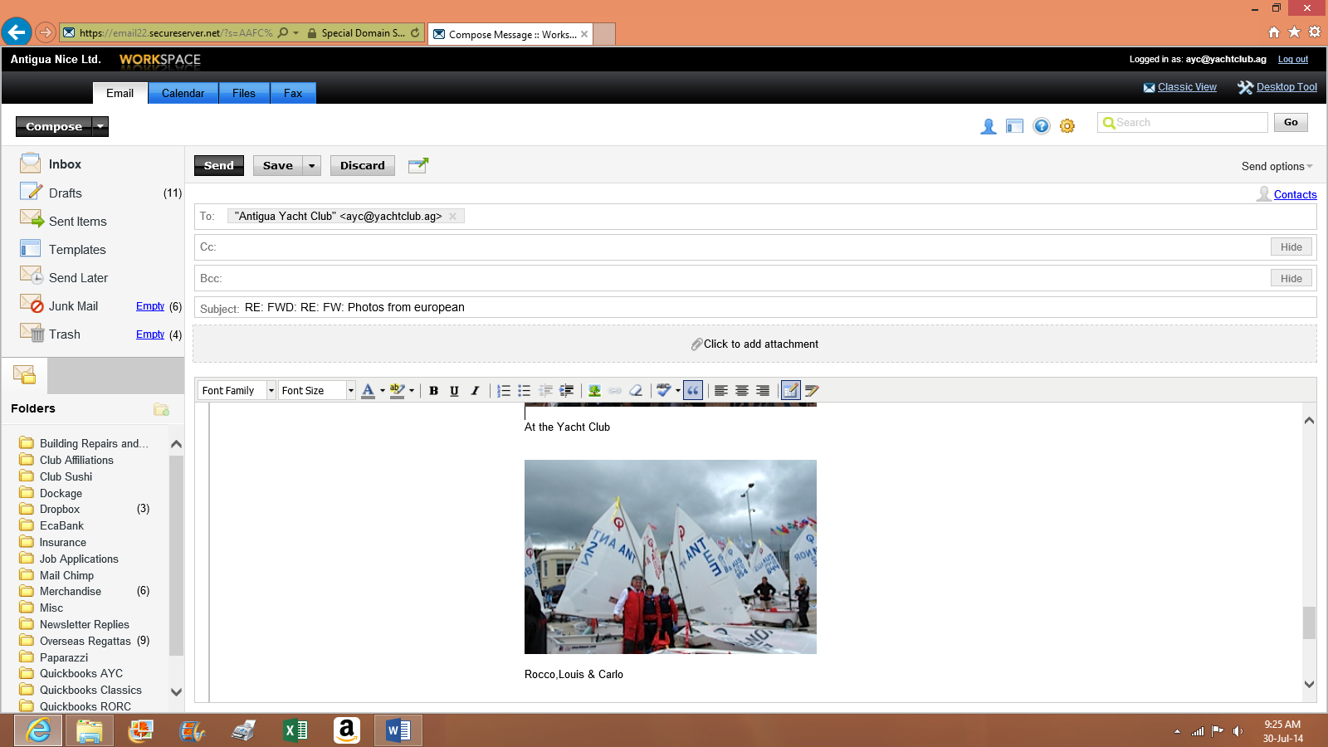
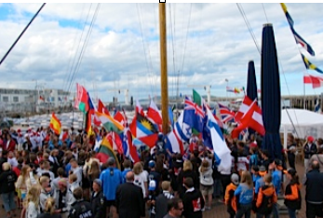
At the Yacht Club Carlo, Rocco and Louis

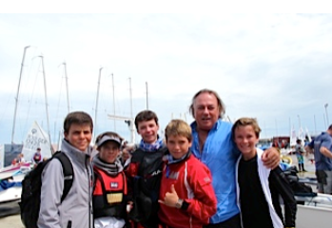

With Enzo, European Champion

