What a fantastic beginning to the Budget Marine High Tide Series 2017. We had 9 yachts in 2 classes and classic Caribbean sailing conditions with 15 knots of wind and 1.5M seas with sunny skies.
Thanks to Race Committee, Clare, Steve and Carol and to Maiwenn and Snowy for mark boat duties and to AYC staff for getting the marks ready and dealing with entries.
The results for race 1 are
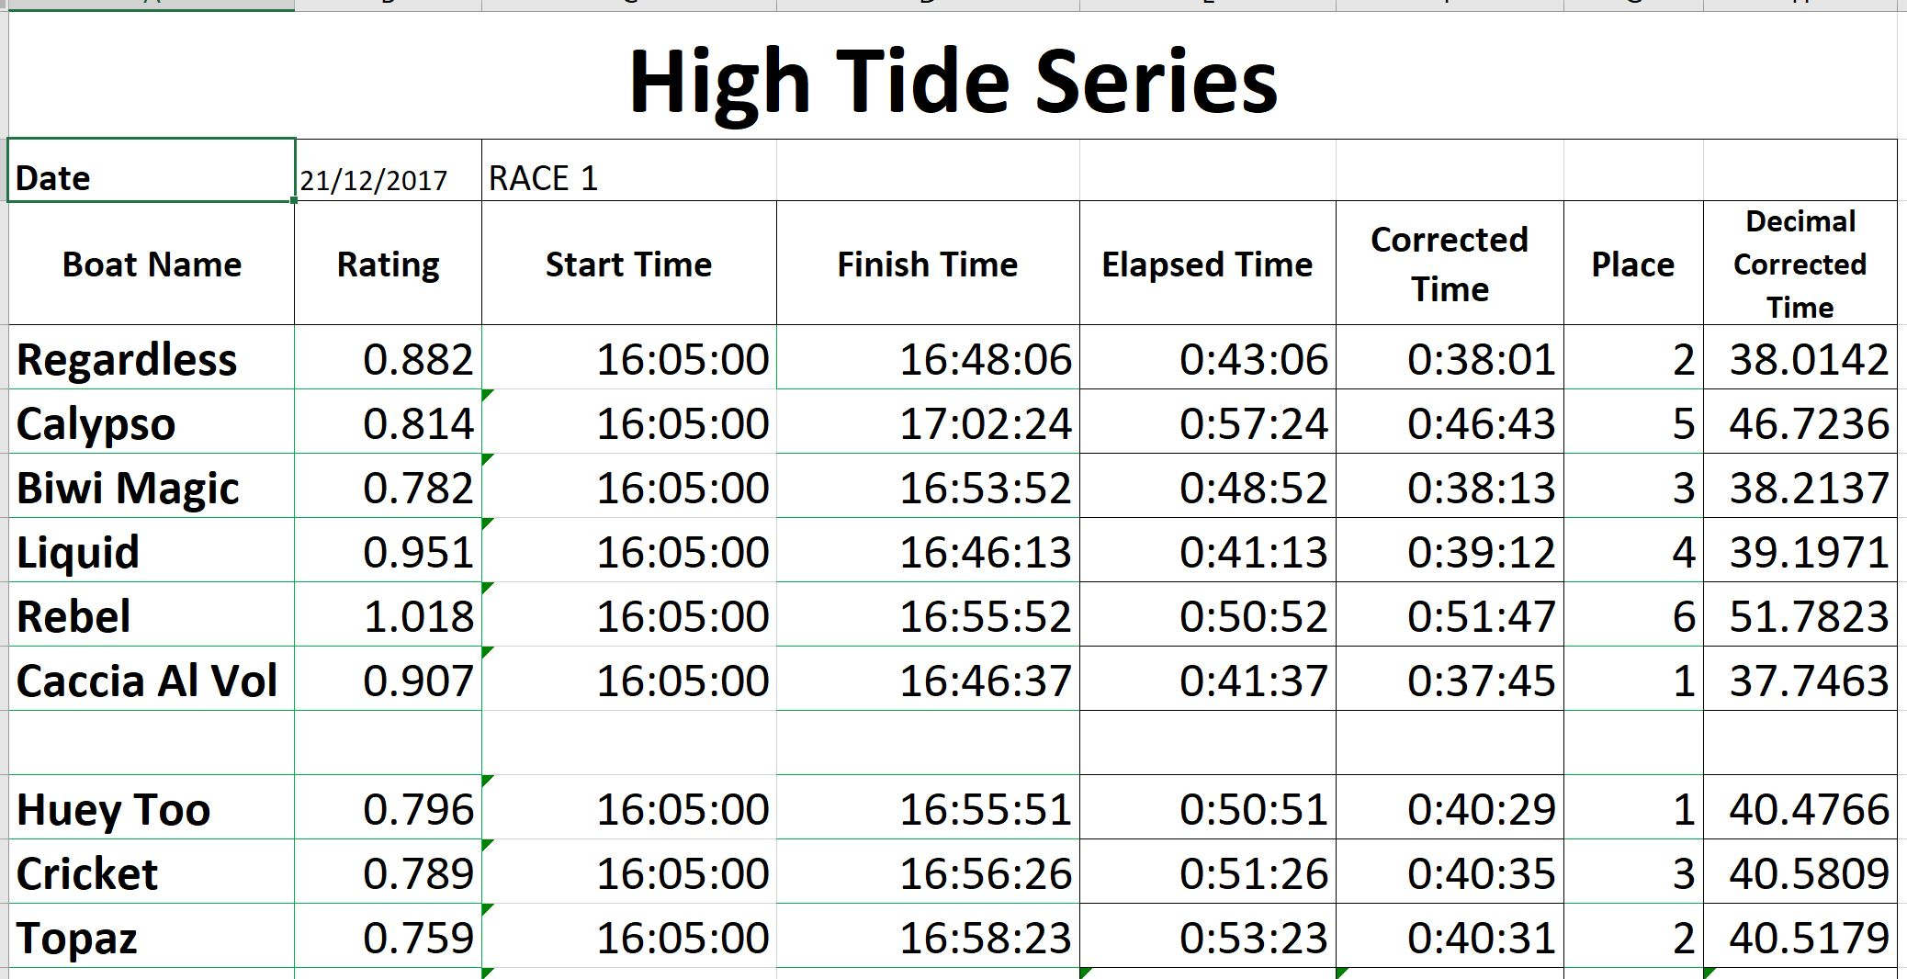
And series standings are.
